**TESTING THE BCP PLAN**

1. **Identification of Critical Activities/Function and Services**

NigComSat has identified some of the critical activities and function using the Business Activity Identification Template (BAIT) as seen on the table below.

|  |  |  |
| --- | --- | --- |
| **PRIORITY** | **CRITICAL FUNCTION/ACTIVITY** | **DESCRIPTION** |
| 1 | Monitoring Satellite within Longitude& Latitude | Station keeping operation (EWSK &NSSK) |
| 2 | Eclipse operation management | Satellite battery management |
| 3 | Space event management | Satellite bolometer protection |
| 4 | Telemetry monitoring and analysis | Satellite health status and analysis |
| 5 | Payload operations | Satellite TWTA monitoring |
| 6 | Interference Management | Inter satellite frequency coordination |
| 7 | Military Security | Security bound traffic for the Military |
| 8 | E – Government | Secure E – Government traffic via GBB |
| 9 | Broadband Services | Broadband shared services to both private & public |
| 10 | Broadcasting Services | Broadcast to public and private |
| 11 | IP Transponder Lease | Tx lease by private industries |
| 12 | Infrastructure Lease | Tx leasing by public institution NNC |
| 13 | Colocation | Colocation & hosting services |
| 14 | Spectrum Management | Monitoring of Power, Carrier-to-Noise, Bandwidth, Temperature etc |
| 15 | ESVA | Earth Station Verification Acceptance |
| 16 | CSM Operations | Carrier Spectrum Monitoring |

1. **Risk Identification**

NigComSat has also listed possible risks that could negatively impact the functions/activities.

|  |  |  |  |
| --- | --- | --- | --- |
| **Function/activities** | **Risk** | **Services** | **Risk** |
| Monitoring Sat Long & Lat | Non-adherence to maneuver planning standards & strategy | Satellite launch operation | Non-adherence to maneuver planning standards & strategy |
| Eclipse operation management | Software malfunctioning | Payload management |  |
| Space event management | operational error / Software malfunction | Optimum pointing | Software malfunctioning |
| Telemetry monitory | Software malfunctioning | Longitude repositioning | Non-adherence to maneuver planning standards & strategy |
| Payload operation | Non-adherence to operational standards |  |  |
| Interference management | Lack of frequency coordination |  |  |
| Military | Competition from ISPs | Satellite backhaul | Unavailability of C – band due to imminent 5G deployment |
| E – Government | Competition from ISPs | Uplink Services | Inadequate uplink equipment |
| Broadband Services | Non optimal performing uplink facility | Content aggregation | Inadequate active & passive devices for content aggregation |
| Broadcasting Services | Insufficient transponders to cater for increased request for new services |  |  |
| IP Transmit Lease | Fierce competition from other ISPs |  |  |
| Infrastructure Lease | Lack of redundancy and spares |  |  |
| Colocation | Poor electricity and cooling system |  |  |
| Spectrum Management | Bad Equipment | CSM | Equipment Failure |
| RF Link Maintenance | Equipment Failure | Payload Management | Software Failure |
| Calibration of Spectrum Analyzer | Lack of Expertise | ESVA | Software Failure |

Using the Risk Register, NigComSat will then assess these risks to find the most critical for immediate attention.

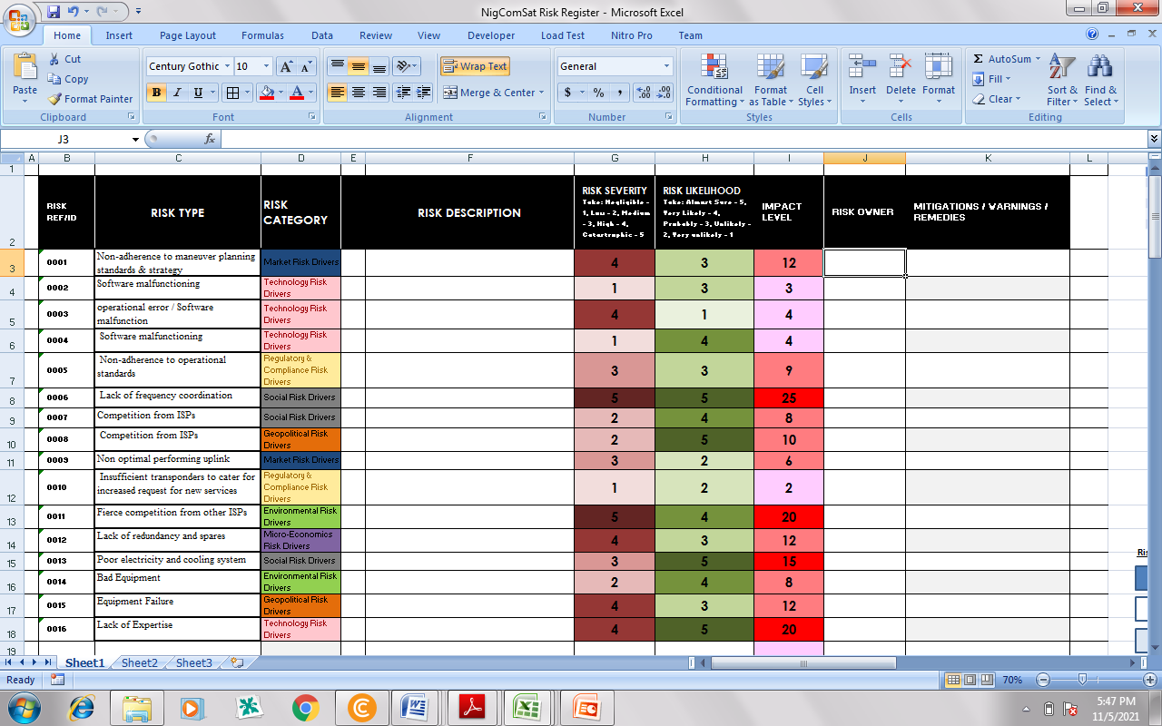

1. **Risk Impact**

Risk Impact Level = Severity of Impact x Likelihood of Occurrence

|  |  |  |  |  |  |
| --- | --- | --- | --- | --- | --- |
| **Severity**  **Likelihood** | **NEGLIGIBLE** | **LOW** | **MEDIUM** | **HIGH** | **CATASTROPHIC** |
| **VERY UNLIKELY** |  | 0010 | 0002 |  |  |
| **UNLIKELY** |  |  |  | **0007** | **0008** |
| **PROBABLY** |  |  | 0005 |  | 0013 |
| **VERY LIKELY** | 0003 |  | 0001 |  | 0016 |
| **ALMOST SURE** |  |  |  | 0011 | 0006 |

1. **BIA**

**BUSINESS IMPACT ANALYSIS TEMPLATE**

*(You will need to complete a BIA for each of your key functions or services).*

|  |  |
| --- | --- |
| Key Function / Service: | Interference management (0006) |

*The table below details, over time, the impact the loss of this function would have on your ability to meet your organization’s Aim and Objectives and the impact on your stakeholders.*

|  |  |  |
| --- | --- | --- |
| **Time of operation** | **Impact Description**  *Negligible, Low, Medium, High and Catastrophic* | **Example of Impact to Service** |
| First 24hrs | High |  |
| 24 – 48 hrs | High |  |
| Up to 2 week | High |  |
| Up to 2 weeks | High |  |

*Consider the maximum length of time that you can manage a disruption to this key function / service without it threatening your organisations viability. What point in time would you need to resume in the event of disruption? This is called the Recovery Time Objective (RTO).*

|  |  |
| --- | --- |
| Recovery Time Objective: | 2 weeks |

*The table below is to lists the resources required to meet Recovery Time Objective (RTO) for each activity/function or service after ascertaining when a business activity must be recovered.*

|  |  |  |  |  |  |  |  |  |  |  |  |
| --- | --- | --- | --- | --- | --- | --- | --- | --- | --- | --- | --- |
| **Time of operation** | **Activity/**  **Function** | **People** | **Data and Information** | **Buildings, work environment and utilities** | **Facilities, equipment and consumable** | **ICT Systems** | **Transportation** | **Finance** | **Partners and Suppliers** | **Any legal, statutory and contractual obligations** | **Others** |
| First 24hrs | Interference management (0006) | 17 |  |  |  | 20 Desktop, 3 laptops, |  | $20m |  |  |  |
| 24 – 48 hrs |  |  |  |  |  |  |  |  |  |  |
| Up to 2 week |  |  |  |  |  |  |  |  |  |  |

1. **Plan Activation**

This plan shall be activated by the following

|  |  |  |  |
| --- | --- | --- | --- |
| **S/N** | **NAMES** | **DESIGNATION** | **CONTACT** |
| 1 | Prof. Ayo |  |  |
| 2 | Dr. Mohammed |  |  |
| 3 | Engr. Festus |  |  |
| 4 | Engr. Rufus |  |  |
| 5 | Dr. Amir |  |  |

1. **Relocation Strategy and Alternate Business Site**

Below is the location and address of an alternate business site where recovery should take place.

|  |  |
| --- | --- |
| **Primary Location** | **Alternate Business Site** |
|  |  |

1. **Incident Response Plan**

**Immediate Response Checklist**

*(To be completed by the Incident Response Team Lead)*

|  |  |  |
| --- | --- | --- |
| **Incident Response** | ✓ | **Actions taken** |
| Have you:   * assessed the severity of the incident? |  |  |
| * evacuated the site if necessary? |  |  |
| * accounted for everyone? |  |  |
| * identified any injuries to persons? |  |  |
| * contacted Emergency Services? |  |  |
| * implemented your Incident Response Plan? |  |  |
| * started an Event Log? |  |  |
| * activated staff members and resources? |  |  |
| * appointed a spokesperson? |  |  |
| * gained more information as a priority? |  |  |
| * briefed team members on incident? |  |  |
| * allocated specific roles and responsibilities? |  |  |
| * identified any damage? |  |  |
| * identified critical activities that have been disrupted? |  |  |
| * kept staff informed? |  |  |
| * contacted key stakeholders? |  |  |
| * understood and complied with any regulatory/compliance requirements? |  |  |
| * initiated media/public relations response? |  |  |

1. **Incident Response Team/Roles and Responsibilities**

|  |  |  |  |  |  |  |
| --- | --- | --- | --- | --- | --- | --- |
| **Team Lead:** Dr. Kwame  **Designation:**  **Contact:** | | | **Asst. Team Lead:** Engr. Freeman  **Designation:**  **Contact:** | | | |
| ***Emergency Responsibilities:***   * *ensure the Business Continuity Plan has been activated* * *oversee smooth implementation of the response and recovery section of the plan* * *determine the need for and activate the use of an alternate operation site and other continuity tasks* * *communicate with key stakeholders as needed* * *provide important information to the Communication Officer for distribution*   *keep key staff apprised of any changes to situation.* | | | | | | |
| **Team Members** *(As dimed appropriate)* | | | | | |  |
| **S/N** | **FULL NAME** | **DESIGNATION** | | **ASSIGNED ROLE** | **CONTACT**  **Home/Work** | **Email**  **Address** |
|  |  |  | |  |  |  |
|  |  |  | |  |  |  |

1. **Business Contact Lists**

*Details of some important business contacts with key suppliers and customers.*

|  |  |  |  |  |
| --- | --- | --- | --- | --- |
| **Supplier Name** | **Contact** | **Provides** | **Telephone** | **Email** |
| Daga Consult |  | ICT Gadgets | +01254787 | dgConst@gmail.com |
| F&F Nig Ltd |  | Logistics | 23480465700 | F2nigeria@yahoo.com |
|  |  |  |  |  |
| **Customers** | **Contact** | **Provides** | **Telephone** | **Email** |
|  |  |  |  |  |
|  |  |  |  |  |

1. **Incident Log Sheet and Expenses Record should be filled**